Part Number: PT922-12161

Kit Contents
Item # | Quantity Reqd. | Description
1 | 1 | Main Wire Harness
2 | 1 | Switch
3 | 1 | Switch Header
4 | 1 | ECU
5 | 1 | ECU Bracket
6 | 1 | Hardware Kit
7 | 1 | Instruction Card
8 | 1 | LH Light
9 | 1 | RH Light
Hardware Bag Contents
Item # | Quantity Reqd. | Description
1 | 3 | Red Scotchlok (16-22 gauge)
2 | 1 | Blue T-tap (14-18 gauge)
3 | 1 | Thin Foam Tape
4 | 5 | Thick Foam Tape
5 | 25 | 25cm Wire Tie
6 | 2 | 10cm Wire Tie
7 | 1 | M6 Bolt
8 | 1 | M6 Nut
Additional Items Required For Installation
Item # | Quantity Reqd. | Description
1
2
3
Conflicts
Premium Audio (Extension Module)
General Applicability
All iM models
Recommended Sequence of Application
Item # | Accessory
1 | Interior Light Controller (for door sills & lights)
2 | Interior Light Kit
3 | Audio
4
*Mandatory
Vehicle Service Parts (may be required for reassembly)
Item # | Quantity Reqd. | Description
1
2
3
Recommended Tools
Personal & Vehicle Protection | Notes
Safety Glasses
Safety Gloves | Optional
Vehicle Protection | Blankets
Special Tools | Notes
Nylon Panel Removal Tool
Surface Thermometer | Infrared Non-contact
Heat Gun | Master Heat Gun HG-301A or equivalent
Installation Tools | Notes
Ratchet
Socket | 10mm, 12mm
Extension | 6”
Torque Wrench | 48 in-lbf (5.4 N-m)
Wrench | 10mm
Pliers | Needle Nose
Side Cutter
Pick Tool
Center Punch
Drill | w/ 6mm bit & drill stop
Hole Deburring Tool
Screwdriver | Phillips #2
Masking Tape
Special Chemicals | Notes
Cleaner | VDC Approved or mild, water-based solvent free
Legend
STOP: Damage to the vehicle may occur. Do not proceed until process has been complied with.
OPERATOR SAFETY: Use caution to avoid risk of injury.
CAUTION: A process that must be carefully observed in order to reduce the risk of damage to the accessory/vehicle and to ensure a quality installation.
TOOLS & EQUIPMENT: Used in Figures calls out the specific tools and equipment recommended for this process.
REVISION MARK: This mark highlights a change in installation with respect to previous issue.
SAFETY TORQUE: This mark indicates that torque is related to safety.

Care must be taken when installing this accessory to ensure damage does not occur to the vehicle. The installation of this accessory should follow approved guidelines to ensure a quality installation.

These guidelines can be found in the "Accessory Installation Practices" document.

This document covers such items as:-
- Vehicle Protection (use of covers and blankets, cleaning chemicals, etc.).
- Safety (eye protection, rechecking torque procedure, etc.).
- Vehicle Disassembly/Reassembly (panel removal, part storage, etc.).
- Electrical Component Disassembly/Reassembly (battery disconnection, connector removal, etc.).

Please see your Toyota dealer for a copy of this document.

Prepare for the Installation.
  - Install DCC fuse, if necessary.
  - Check the following for damage or malfunction:
    - Internal and external trim & body work.
    - Radio pre-set stations.
    - Automatic climate control systems (i.e. temperature control, A/C, fan speed, vent modes, rear defrost, etc.)
    - Other functions (i.e. security, hazard lights, etc.).

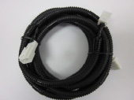
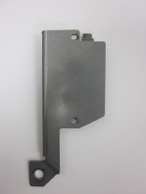
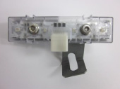
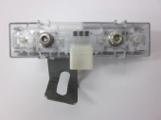
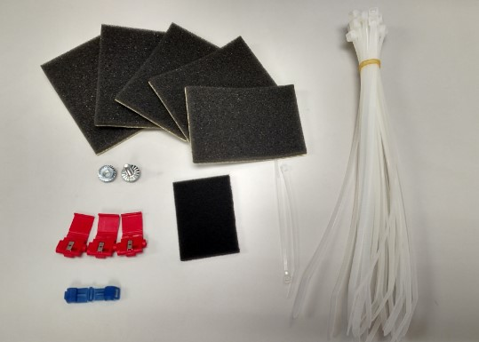
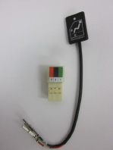
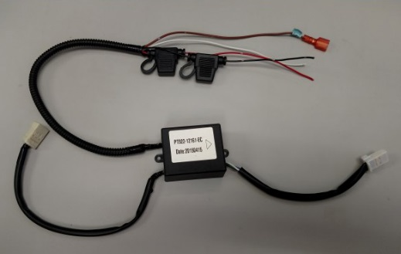
  - Check the kit contents (Fig. 1-1).
Interior Light Kit ECU
Fig. 1-1
Vehicle Wire Harness
Driver Side Light
Passenger Side Light
ECU Mounting Bracket
Switch
Hardware Bag Contents

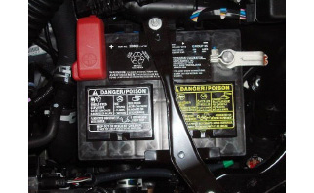
  - Remove the negative battery cable (Fig. 1-2).
Fig. 1-2
10mm wrench or socket & ratchet
CAUTION: Do not work on the vehicle while the battery’s negative terminal is connected. Working on the vehicle with the battery connected may result in a short circuit during the installation.
CAUTION: Do not touch the positive terminal with hands or any tool.

Disassemble the Vehicle.
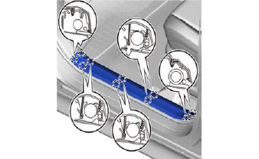
  - Use a panel removal tool to disengage the 2 claws and 8 clips to remove the front left and front right inner door sill plates (Fig. 2-1).
Fig. 2-1
Panel removal tool
NOTE: Remove the claws first when removing the door sill plates.

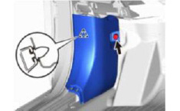
  - Remove the front left and front right inner cowl cover (Fig. 2-2).
Fig. 2-2
Panel removal tool
    - Remove the retaining nut.
    - Use a panel removal tool to unclip the cowl side cover.
NOTE: If the clip remains in the body, carefully remove it and reinsert the clip into the panel.

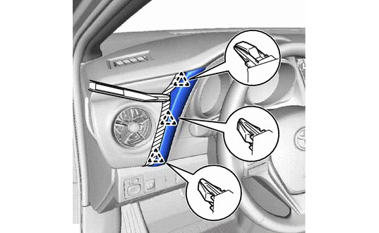
  - Remove the instrument cluster fascia (Fig. 2-3).
Fig. 2-3
Panel removal tool
    - Apply protective tape.
    - Remove the plastic side piece.

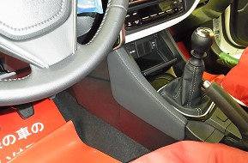
  - Remove the driver side lower IP finish panel (Fig. 2-4).
Fig. 2-4
Panel removal tool

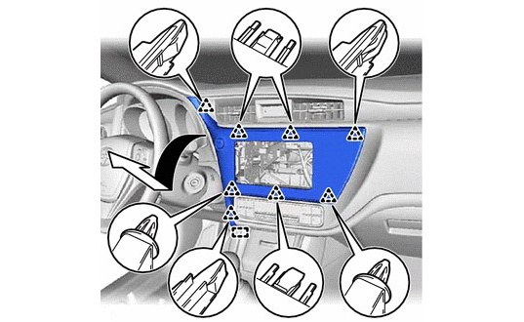
  - Remove the audio trim panel (Fig. 2-5).
Fig. 2-5
Panel removal tool
    - Detach the first clip at the right top corner of the panel.
    - Detach the remaining clips along the top of the panel.
CAUTION: Since the top-left corner is extended from the main body of the trim panel, use special care so as not to damage it.
    - Detach the center and bottom clips.

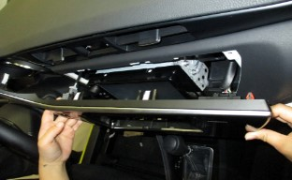
    - Disconnect the two connectors connected to the back of the trim panel (Fig. 2-6).
Fig. 2-6
Connectors
  - Slide the tab at the bottom left corner of the panel outward to the left and remove the panel.

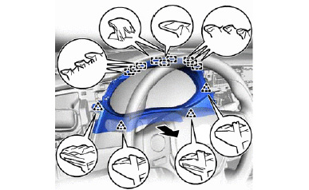
  - Remove the instrument cluster finish panel assembly (Fig. 2-7).
Fig. 2-7
Panel removal tool
    - Place protection on the steering column.
    - Adjust the steering wheel down and back.
    - Disengage the 4 clips and 9 guides to remove the instrument cluster finish panel assembly.
  - Remove the combination meter assembly.
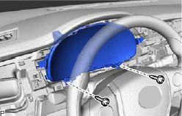
    - Remove the 2 screws (Fig. 2-8).
Fig. 2-8
Phillips screwdriver
    - Adjust steering column out and down.

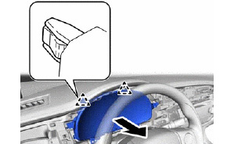
    - Disengage the 2 clips (Fig. 2-9).
Fig. 2-9
    - Disconnect the 2 connectors and remove the combination meter assembly.

  - Remove the side cover.
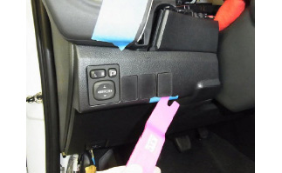
    - Apply protective tape (Fig. 2-10).
Fig. 2-10
Panel removal tool
    - Remove the right most blank switch knockout (Fig. 2-10).

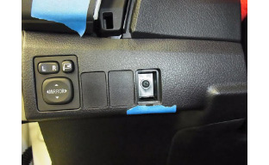
    - Remove the screw (Fig. 2-11).
Fig. 2-11
Philips screwdriver

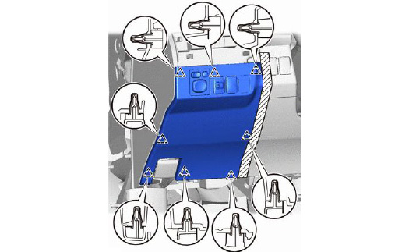
    - Protect the interior panels with tape (Fig. 2-12).
Fig. 2-12
Panel removal tool
NOTE: Failure to use protective tape on the interior panels may result in damage to the vehicle.
    - Disengage the 8 clips to remove the side cover (Fig. 2-12).
    - Disconnect the wires on the side cover and set it aside.

  - Remove the under dash cover.
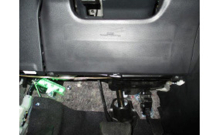
    - Remove 2 the screws (Fig. 2-13).
Fig. 2-13
Philips screwdriver
Screw
Screw
Tab
    - Release the center tab (Fig. 2-13).

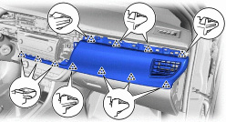
  - Use a nylon panel removal tool to disengage the 11 claws, 11 clips and guide to remove the center No.1 instrument panel (Fig. 2-14).
Fig. 2-14
Panel removal tool

  - Remove the glove box.
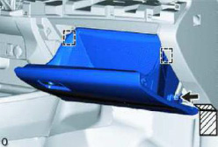
    - Protect the interior panels with tape (Fig. 2-15).
Fig. 2-15
NOTE: Failure to use protective tape on the interior panels may result in damage to the vehicle.
    - Disconnect the glove box door stopper assembly (arrow, Fig. 2-15).
    - Release the 2 stoppers and open the glove box door until it is horizontal (boxes, Fig. 2-15).

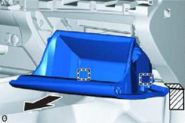
    - Pull the glove box towards the rear of the vehicle to detach the 2 hinges (Fig. 2-16).
Fig. 2-16

Disassemble the Junction Box.
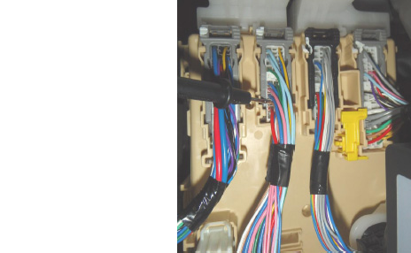
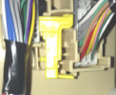
  - Disconnect the C connector (Fig. 3-1 and refer to Fig. 4-2 on the next page).
Fig. 3-1
Pick tool
B
C
A
    - Use a pick tool to gently pry the yellow locking tab back.
    - Shift the locking tab to the left to release the connector.

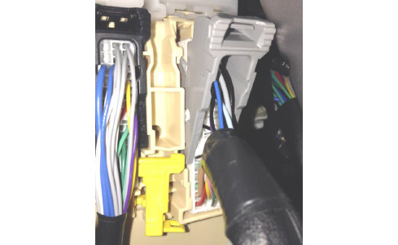
  - Disengage the grey locking tab and remove the wire harness connector (Fig. 3-2).
Fig. 3-2

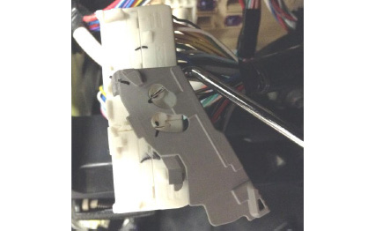
  - Use a pick tool to remove the locking tab from the connector (Fig. 3-3).
Fig. 3-3
Pick tool
  - Remove junction block connectors A & B (Fig. 3-1 & refer to Fig. 4-2 on the next page).

Install the Taps in the Junction Box.
Toyota iM Interior Light Kit Wiring
Table 4-1
Junction Block Pin | Junction Box Color | Interior Light Kit Wire Color
C-42 | Red (Red Scotchlok) | Red
B-25 | Black (Red Scotchlok) | Black
C-54 | White (Red Scotchlok) | White
A-8 | Brown (Blue T-Tap) | Brown
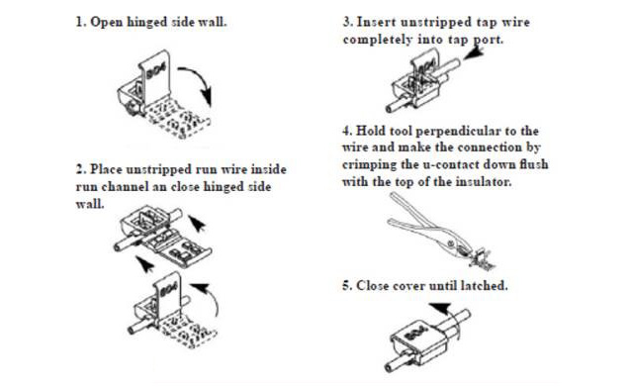
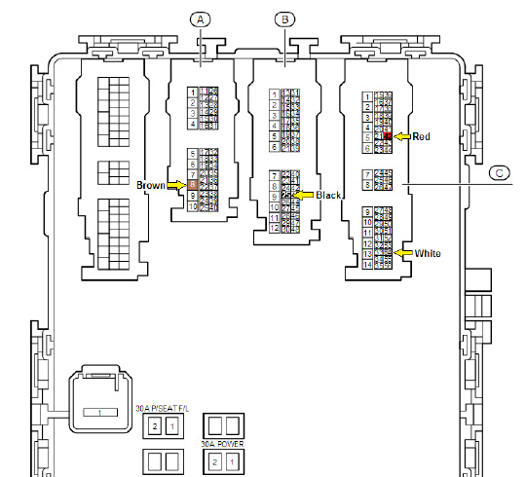
  - Use the provided red Scotchloks to lock in the red, white and black wires (Steps 1-2 in Fig. 4-1; Fig. 4-2 and Table 4-1).
Fig. 4-1
Fig. 4-2
CAUTION: This area contains more than one black wire – be sure to select the correct pin location
Pliers
  - Use the blue T-tap to tap the brown wire (Fig. 4-1, Fig. 4-2 and Table 4-1).
NOTE: Be sure to use the correct color when tapping each wire and place the taps as far from the connector as possible.

Prepare and Mount the Light Controller ECU.
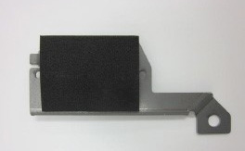
  - Remove the adhesive backing on the thin foam tape and secure it onto the bracket (Fig. 5-1).
Fig. 5-1
Thin foam tape

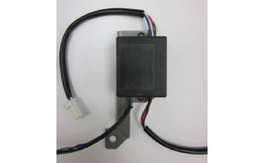
  - Orient the ECU as shown with the 5 pin ECU harness pointing toward the top of the bracket (Fig. 5-2).
Fig. 5-2
Bottom of bracket
Top of bracket
5-pin ECU harness

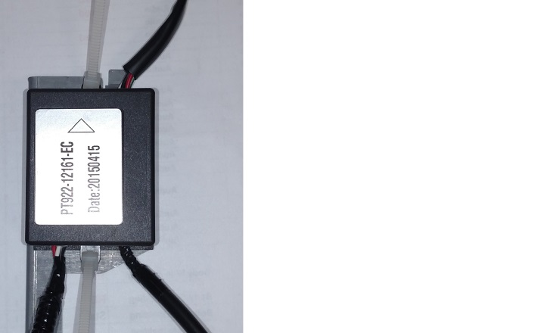
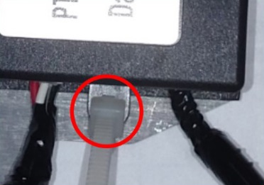
  - Attach the ECU to the bracket with the provided small wire ties (Fig. 5-3).
Fig. 5-3
Wire ties
Side cutters
WARNING: DO NOT OVERTIGHTEN THE WIRE TIES OR THE TABS ON THE ECU WILL BREAK. GET THE TIES SNUG BUT STOP BEFORE THE TABS BEND.
NOTE: Ensure the wire tire lock points towards the module or front of the bracket (circle, Fig. 5-3).
  - Trim all wire ties.

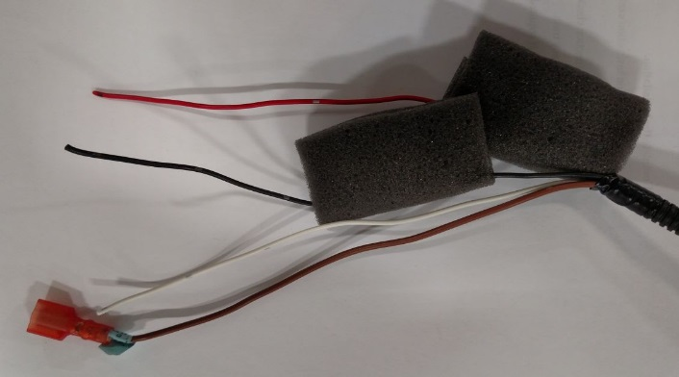
  - Wrap both fuses with the thick foam tape (Fig. 5-4).
Fig. 5-4
Tape #1
Tape #2

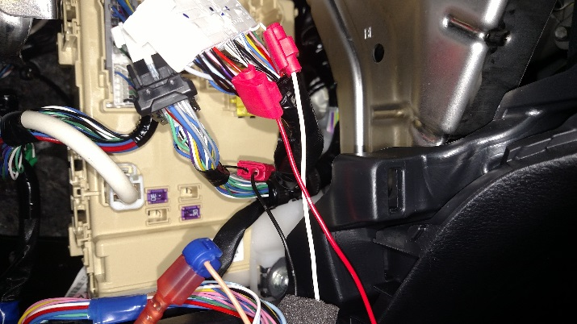
  - Following Table 4-1 in Step 4, connect the ECU wires to the appropriate Scotchlok (see Fig. 4-1, Steps 3-5 for Scotchlok tap procedure) or T-tap in the junction box (Fig. 5-5).
Fig. 5-5

NOTE: Make sure to reinstall the locking tabs to each connector.
  - Insert the ECU bracket tab into the hole on vehicle dashboard support.
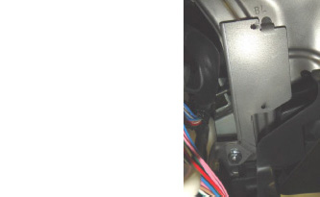
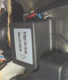
  - Use the 6.25mm hole on the bracket and the M6 bolt and nut provided in the kit to mount the ECU (Fig. 5-6)
Fig. 5-6
M6 nut & bolt
Light kit ECU
ECU removed for clarity only
10mm socket & ratchet

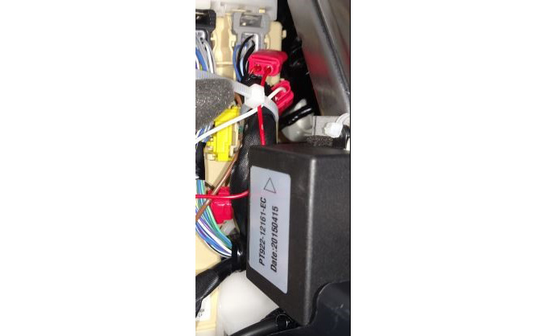
  - Reconnect the vehicle connectors and use a wire tie to bundle the ECU wires to the vehicle harness (Fig. 5-7).
Fig. 5-7
Wire tie #1
NOTE: Make sure all connectors lock properly and the yellow locking tab is back in its original position.

Install the Knockout Switch.
  - Remove the center knockout blank from the left side panel, removed in Step 2(i) (Fig. 6-1).
Fig. 6-1
  - Use the provided template to drill a 6mm diameter hole (use a drill stop set at 5mm, Fig. 6-2) in the knockout. Deburr the hole.
NOTE: The hole is not centered in the knockout. Use the fixture for proper location.
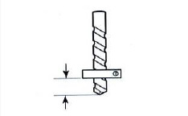
CAUTION: Be careful when handling sharp objects to avoid risk of injury.
Fig. 6-2
6mm drill bit & drill and deburring tool
5mm

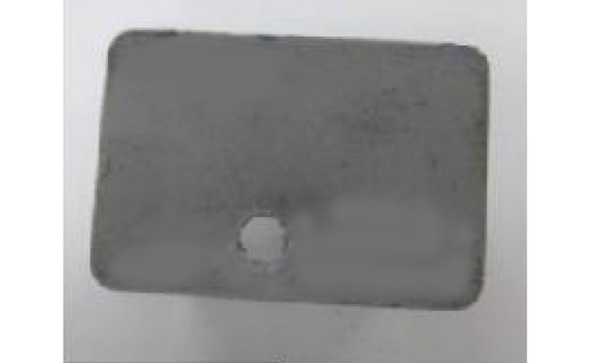
  - The plastic switch blank should look like the one pictured in Fig. 6-3.
Fig. 6-3
  - Clean the top surface of the knockout where the switch will be mounted.
NOTE: Verify the working temperature is between 70-100 ºF (21-38 ºC) for proper adhesion.
  - Route the switch wires through the hole.
  - Remove the adhesive backing and stick the switch to the knockout.
NOTE: Test the switch fitment before removing the adhesive backing to ensure the switch is mounted straight.
NOTE: Do not touch the adhesive.

  - Attach the switch wires to the switch connector.
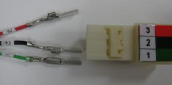
    - The wire colors and numbers should match the color and number of the connector slots (Red to Red, Black to Black, Green to Green and 3 to 3, 2 to 2, 1 to 1) (Fig. 6-4).
Fig. 6-4

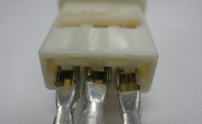
    - Position the pins in the proper orientation before inserting them into the connector (Fig. 6-5).
Fig. 6-5
    - Check each wire after inserting it to make sure the terminals are locked properly.
    - Press down on the pin lock to lock in the terminals.
    - Wrap the switch connector with half of a piece of foam tape.
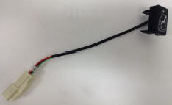
  - Verify the completed assembly (Fig. 6-6).
Fig. 6-6

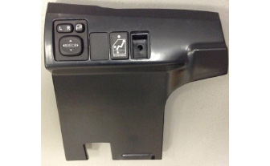
  - Install the switch into the left side panel (Fig. 6-7).
Fig. 6-7

Install the Lights.
  - Install the driver side light.
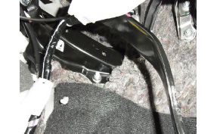
    - Remove the nut (Fig. 7-1).
Fig. 7-1
Mounting nut
Mounting slot
Clutch pedal
12mm socket & ratchet

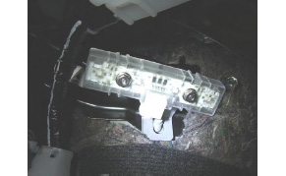
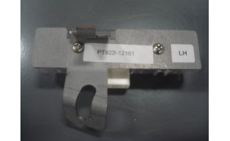
    - Mount the left side light module (Fig. 7-2 & Fig. 7-3).
Fig. 7-3
Fig. 7-2
NOTE: Some pressure may be necessary to get the light to seat properly in the tab and over the stud.

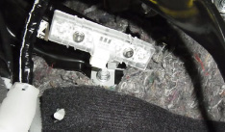
    - Reinstall the mounting nut and tighten it (Fig. 7-4).
Fig. 7-4
12mm socket & ratchet

  - Install the passenger side light.
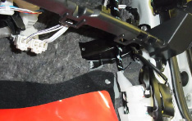
    - Remove the nut (Fig. 7-5).
Fig. 7-5
Mounting nut
Mounting slot
12mm socket & ratchet

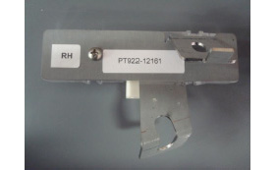
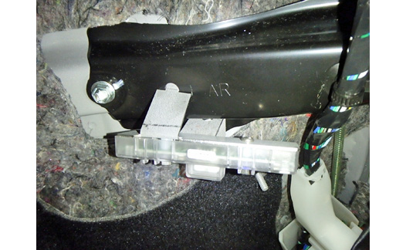
    - Mount the right side light module (Fig. 7-6 & Fig. 7-7).
Fig. 7-6
Fig. 7-7
NOTE: Some pressure may be necessary to get the light to seat properly in the tab and over the stud.

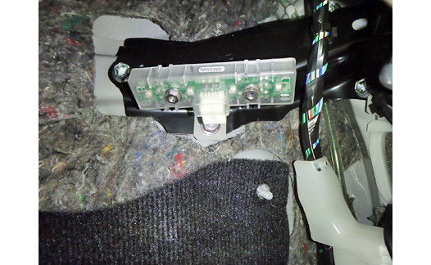
    - Reinstall the mounting nut and tighten it (Fig. 7-8).
Fig. 7-8
12mm socket & ratchet

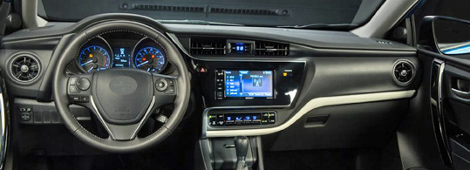
Install the Wire Harness.
Steps j-k
Light
Steps d-e
Step f
Step g
Steps h-i
Steps a-c
Light
ECU
Junction box
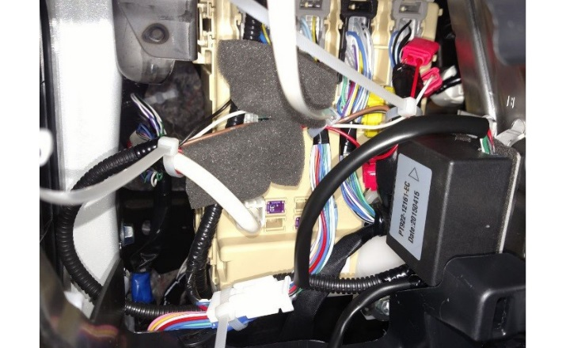
  - Connect the main wire harness to the five pin connector from the top cable of the ECU (ellipse in Fig. 8-1).
Fig. 8-1
Wire tie #3
Wire tie #2
Wire tie #1
Wire tie #4
  - On the driver side, route the ECU cables and wire tie them in the three locations shown, #2 through #4 (Fig. 8-1). Wire tie #1 was installed in Step 5(i).
CAUTION: Do not route the harness where it can interfere with the accelerator and brake pedals or the steering controls.
    - Avoid sharp edges and locations that could pinch the wire.
    - Do not secure wire ties on bare wire.
    - Provide extra slack when routing on the steering wheel column.

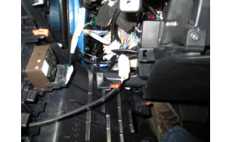
  - Connect the three pin switch connector to the switch header (Fig. 8-2).
Fig. 8-2
3 pin connector

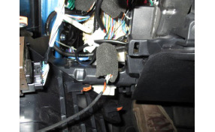
  - Wrap the connector with the provided foam tape (Fig. 8-3).
Fig. 8-3
Foam tape

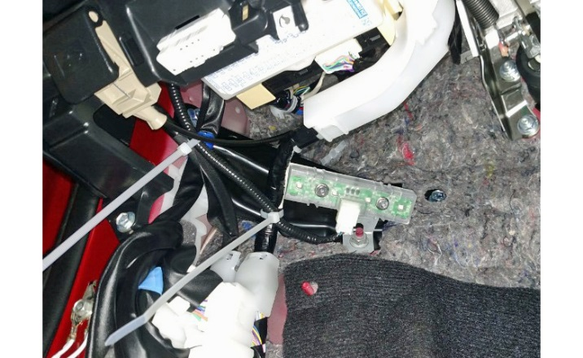
  - Route the main harness (pink harness) towards the LH Light Module and wire tie it in two locations (Fig. 8-4).
Fig. 8-4
Wire tie #6
Wire tie #5
CAUTION: Do not secure the harness to the hood release cable (dashed red line, Fig. 8-4).
  - Connect the 5 pin connector to the light module.

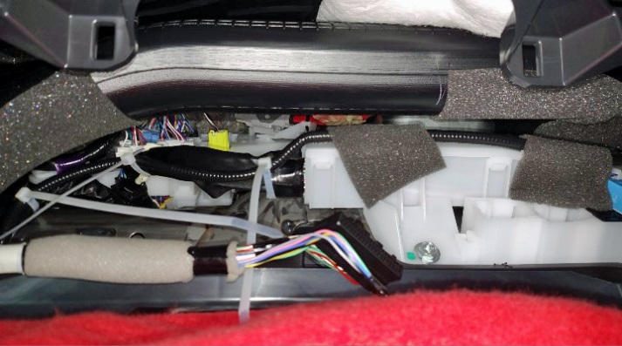
  - Route the main harness (pink line) above and around the steering wheel column, towards the RH Light Module. Wire tie the harness in three locations and tape the harness in two locations (Fig. 8-5).
Fig. 8-5
#1 #2
Foam tape
#7 #8 #9
Wire tie

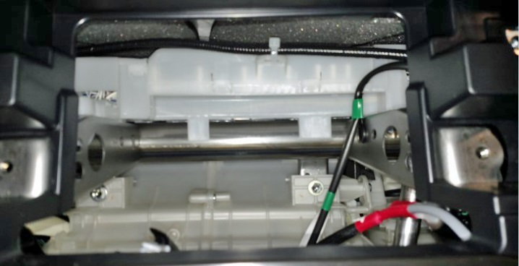
  - Route the main harness (pink line) behind the radio area and secure it with a wire tie to the slot in the white plastic wire box (Fig. 8-6).
Fig. 8-6
Wire tie #10
`

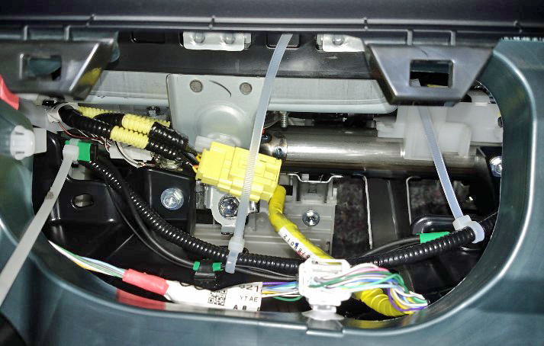
  - Route the main harness (pink wire) above the glove box area and wire tie it in the three locations (Fig. 8-7).
Fig. 8-7
Wire tie #11
Wire tie #12
Wire tie #13
CAUTION: Do not secure the harness to the yellow airbag harnesses.

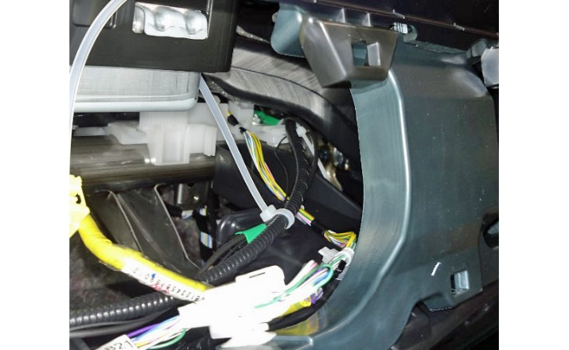
  - Route the main harness (pink line) towards the RH Light Module, passing above and behind the white plastic piece, and wire tie in one location (wire tie #14, Fig. 8-8).
Wire tie #14
Wire tie #13
Fig. 8-8

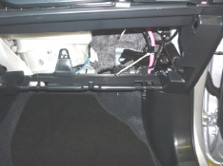
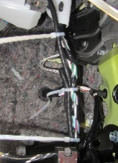
  - Route the main harness (pink line) down towards the LH Light Module and wire tie it in three locations (Fig. 8-9).
Fig. 8-9
Wire tie #16
Wire tie #15
Wire tie #17

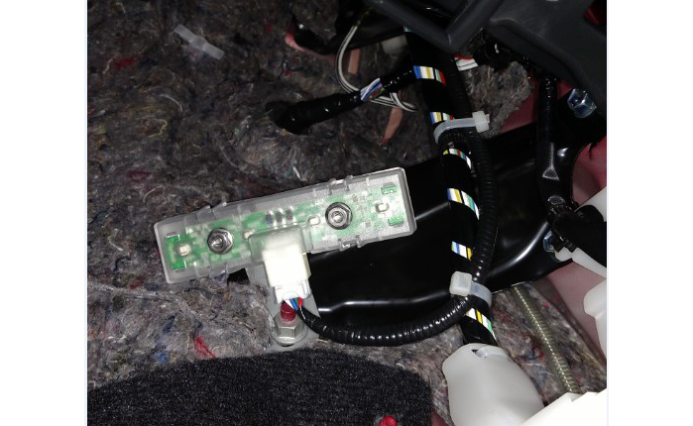
  - Route the main harness (pink line) and wire tie it in two locations (Fig. 8-10).
Fig. 8-10
Wire tie #18
Wire tie #19
  - Connect the five pin connector of the main harness (pink line) to the light module.
  - Trim all wire ties.

Perform a Function Test.
  - Temporarily reconnect the negative battery cable (Fig. 9-1).
Fig. 9-1

CAUTION: Do not touch the positive terminal with hands or any tool.
  - If required, install a 30A fuse.
  - Open a door. The interior light kit should light up. The switch LED should be ON.

  - With a door open, press the illumination switch to cycle through all 7 of the colors (Fig. 9-2). (Two blue color positions exist when a door is open.)
Fig. 9-2
Blue Turquoise Green Yellow Red Purple White Blue

  - With the key in the OFF position, close all doors (including the trunk). The interior light kit should turn off. The switch LED should turn OFF too.
  - With all doors closed, turn the key to ACC/ON. The switch LED should come ON.
  - With all doors closed and with the key in the ACC/ON position, press the switch to cycle through all 7 of the colors and the off position (Fig. 9-3).
Fig. 9-3
Blue Turquoise Green Yellow Red Purple White Off
  - Turn the key to the OFF position.
  - Disconnect the negative battery cable and remove the 30A fuse.

CAUTION: Do not touch the positive terminal with hands or any tool.

Reassemble the Vehicle.
  - Reassemble vehicle interior panels in the opposite order of disassembly.
  - Be sure to reconnect any disconnected connectors and verify that the panels fit together properly with no uneven gaps between them.
  - Replace the negative battery cable.

CAUTION: Do not touch the positive terminal with hands or any tool.
  - Torque the negative battery cable to 48 in•lbf (5.4 N•m).
Torque: 48 in•lbf (5.4 N•m)

Complete the Installation.
  - Place the operation instruction card in the glove box.
  - Perform the vehicle function checks.
  - Clean up and remove any trash.
  - Remove the DCC fuse, if required.

Drill Template
Drill Hole
Accessory Function Checks
Open a door
Close doors with key in OFF position
Close doors with key in ACC/ON position
Switch LED
Color selection

Vehicle Function Checks
All exterior lights
Airbag Light
Lock/Unlock button
Instrument Cluster
Power outside mirrors
Hazard lights
Mirror adjustments
Mirror retraction
Dome lamp

Interior light kit ON
Interior light kit should turn off within a few seconds
Interior light kit should remain on (except if color selection is in the off position)
Switch LED should be ON when a door is open or when key is in ACC/ON position
Color should be selectable when switch LED is illuminated

Brake lights, turn signals and headlights
Light should function normally
Lock/Unlock should function normally
Cluster should function normally
Power outside mirrors should function normally
Hazard lights should function properly
Mirrors should function normally
Mirrors should retract
Dome lamp should function properly
Vehicle Appearance Check
After accessory installation and removal of protective cover(s), perform a visual inspection.

Ensure no damage (including scuffs and scratches) was caused during the installation process.
(For PPO installations, refer to TMS Accessory Quality Shipping Standard.)

